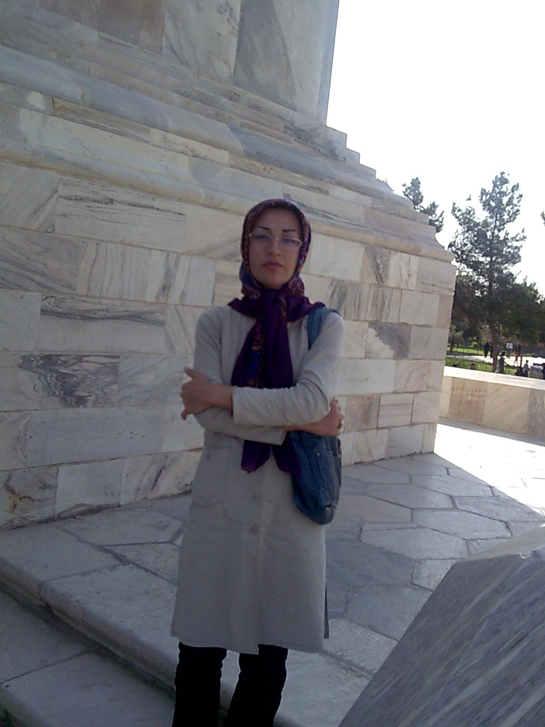

Personal and Contact Information:
First and Last Name: Shirin Hasanvand
Academic Rank:PhD,Assisstant Professor
Personal Email: hasanvand.sh1390@gmail.com
Academic Email: haasanvand.sh@lums.ac.ir
Mobile Number: +989166690887
Office Phone Number: 06633120155
Fax Number: 06633120140
Date of Birth: 22 - 6 - 1982
Marital Status: Married

Education:
BSc: (Field of Study, Name of University, Year Graduated)
Nursing,Lorestan University of Medical Sciences,2004
BSc Thesis: (Title, Supervisor, Advisors)

MSc: (Field of Study, Name of University, Year Graduated)
Medical-Surgical Nursing, Kerman University of Medical Sciences,2007
MSc Thesis: (Title, Supervisor, Advisors)
The effect of back massage on blood pressure and radial pulse in Patients with primary hypertention , Mr Saeed Najafi, Mrs Mansoureh Forozy,Professor Aliakbar Haghdoost

PhD: (Field of Study, Name of University, Year Graduated)
Nursing,Shahid Beheshti University of Medical Sciences,2014
PhD Thesis: (Title, Supervisor, Advisors)
Clinical belongingness experience in bachelor nursing students: a mixed method research. Professor.Tahereh Ashktorab, Professor Naemeh Seyedfatmi,Dr Farid Zayeri

MD: (Field of Study, Name of University, Year Graduated)
MD Thesis: (Title, Supervisor, Advisors)

Resident: (Field of Study, Name of University, Year Graduated)
Resident Thesis: (Title, Supervisor, Advisors)

Fellowship: (Field of Study, Name of University, Year Graduated)
Fellowship Thesis: (Title, Supervisor, Advisors)

Awards & Honors:
First top student , 2004 (Undergraduate degree)
First top student in PhD comprehensive exam, 2011
Top Teacher ,2018
Top nurse,2018
Scientific Position:
1. Assistant Professor of Nursing (Department of Nursing, Lorestan University, during)
2. Associate Professor of Medicine (Department of …, …. University, during)
3. Professor of Medicine (Department of …, …. University, during)

Executive Position:
Director of one of packages for reform and innovation in medical education(virtual education) in LUMS
Teaching Experiences:
Assistant professor: Khorramabad Faculty of Nursing and Midwifery, Lorestan University of Medical Sciences (up 2015 to now)
Lecturer: Sannadaj Faculty of Nursing and Midwifery, Kurdistan University of Medical Sciences (2011-2013)
Lecturer: Khorramabad Faculty of Nursing and Midwifery, Lorestan University of Medical Sciences (2008-2011)

Clinical Experiences:
Medical-Surgical wards(2004-2005)
Neurology ward(2005-2006)

Research Field:
-Nursing education
-Virtual/blended education
-Palliative care
- Complementary and alternative medicine
-Psychometric evaluation
-Mixed-method Research
Grants:
- The relationship between uncertainty and anxiety, depression and quality of life in patients with cancer
- Assessment the effect of emotional intelligence (EI) training on nurses resiliency and general health in ICU
- The Experiences of family Caregivers of Patients with a Tracheostomy at Home.
- Comparison of the effectiveness of rehabilitation through home visit and telephone follow up on self-efficacy in CABG patients and their family caregivers' burden.
- The Impact of Cooperative Learning with the use of the Paired Nursing Student on Empathy and Self-Efficacy in Clinical Performance
- Perception of nursing instructors and students of Lorestan University of Medical Sciences of civil behaviors in academic environments
- A comparison effect of Citrus Aurantium Fragrance and Cranesbill on Anxiety and Severity of Fatigue Patients with Acute Myocardial Infarction
- Translation and psychometric evaluation of Good Nursing Care Scale in the patients of coronary care units in the hospitals of Lorestan province
- Effect of nursing process training by concept mapping in mobile environment on clinical self- efficacy and creativity of nursing students in the field of intensive care
- Improve the quality of Ventilator-Associated Pneumonia (VAP) control in the Intensive Care Unit (ICU): A Participatory Action Research
- Clinical Belongingness Experience in Bachelor Nursing Students
- Translation , Cultural Adaptation and Validation of Belongingness Scale Clinical Placement Experience( BES-CPE)

Supervisor:
- Effect of Flipped Classroom on Self-directed Learning and Metacognitive Awareness of Nursing Students in the Practical Unit of Fundamental of Nursing(Student:Safoura Khodaee)
- Effect of an Educational Intervention on Nursing Students' Civic Index in Lorestan University of Medical Sciences(Student:Fatemeh Farzi)
- The impact of Intensive Care Unit Liaison Nurse Services on Vital Signs and Anxiety of Post-ICU Patients(Student:Atiyeh Beiranvand)
- The impact of Intensive Care Unit liaison nurse Services on anxiety of patient's family caregivers after discharge of the ICU (Student:Khadijeh Mottaghi)
- The Experiences of family Caregivers of Patients with a Tracheostomy at Home.(Student: Saeed Daraei)
- Comparison of the effectiveness of rehabilitation through home visit and telephone follow up on self-efficacy in CABG patients and their family caregivers' burden.(Student: Forouzan Gohari)
- The Impact of Cooperative Learning with the use of the Paired Nursing Student on Empathy and Self-Efficacy in Clinical Performance.(Student: Maryam Kamali)
- Perception of nursing instructors and students of Lorestan University of Medical Sciences of civil behaviors in academic environments.(Student:Maryam Mohammad pour)
- Translation and psychometric evaluation of Good Nursing Care Scale in the patients of coronary care units in the hospitals of Lorestan province.(Student: Fatemeh Bahrami)
- Effect of nursing process training by concept mapping in mobile environment on clinical self- efficacy and creativity of nursing students in the field of intensive care.(Student: Mina Ranjbar Delbar)
Advisor:
- Assessment of Chemotherapy StandardsOriented Training by Smartphone Software on Knowledge, Attitude and Performance.(Student:Zohreh Hojati)
- The effect of telephone training intervention on burden of family caregivers of patients with cancer of oncology Nurses (Student: Mahin Abdi Garavand)
- The Impact of Applying the Comprehensive Unit-Based Safety Program (CUSP) on Safety Culture of Healthcare Providers In Intensive Care Unit.(Student:Zahra Merdasi)
- Nurses' Perception of futile Care and its Relationship with Moral Distress and Job Burn out in Nurses in Critical care Units of Educational Hospitals in Khoramabad city (Student: Paria Rashnoo)
The relationship between uncertainty and anxiety, depression and quality of life in patients with cancer.(Student: Mahnaz Tarhani)
- Assessment the effect of emotional intelligence (EI) training on nurses resiliency and general health in ICU.(Student: Leila Lak)
- A compersion effect of Citrus Aurantium Fragrance and Cranesbill on Anxiety and Severity of Fatigue Patients with Acute Myocardial Infarction.(Student:Raziyeh Shirzadegan)
- Improve the quality of Ventilator-Associated Pneumonia (VAP) control in the Intensive Care Unit (ICU): A Participatory Action Research.(Student:Fereshteh Rashnou)

Papers:
English:
- Tahereh Toulabi,Fereshteh Rashnou,Shirin Hasanvand,Sajad Yarahmadi.promoting thr quality of ventilator-associeted pneumonia control in the intensive care unite :Action research stydy.Tanaffos Journal.2020 (Accepted)
- Shirzadegan, R., Gholami, M., Hasanvand, S., Beiranvand, A.The effects of Citrus aurantium aroma on anxiety and fatigue in patients with acute myocardial infarction: A two-center, randomized, controlled trial. Journal of Herbal Medicine.2020.
- Mahnaz Tarhani, Fateme Goudarzi, Shirin Hasanvand, Farzad Ebrahimzadeh, Maryam Rassouli. Uncertainty, anxiety, depression and the quality of life in patients with cancer. Oncology and Radiotherapy.2020;1(50) :031-039
- Fatemeh Bahrami, Shirin Hasanvand *, Fateme Goudarzi, Nasrin Galehdar, Farzad Ebrahimzadeh, Fardin Heidari. Cardiac Patients' Perception of a Good Nursing Care: A Cross-Sectional Study. International Cardiovascular Research Journal.2020;14(1).
- Hosseinabadi, R., Hasanvand, S.*, Almasian, M., Mirzayee-Sharifi, S.The role of students with practical nursing diplomas in the process of undergraduate nursing education: A qualitative study.Iranian Journal of Nursing and Midwifery Research.2020; 25(1), pp. 76-83.
- S Hasanvand *, M Mohammadi Pour, F Goudarzi, M Rasouli, P Baharvand. The incidence and importance of uncivil behaviors of nursing students: Comparing the perception of educators and students. Future of Medical Education Journal.2019; 9 (4), 16-25
- Jafari Pour, F., Goudarzi, F., Hasanvand, S., Ebrahimzadeh, F., Kvist, T. Psychometric Testing of the Persian Version of the Revised Humane Caring Scale for Patients Admitted to Critical Care Units.Journal of Nursing Measurement.2019; 27(3): 508-523.
- Shirin Hasanvand,Maryam Rassuli,Zahra Mandgari,Naiire Salmani,Farzaneh Moghimkhan. A Critical Review of Instruments Measuring the Quality of Life of Cancer Patients in Iranian Studies and Their Psychometrics Properties. Asian Pacific Journal of Cancer Prevention.2018;20,254-260.
- Mayam Mohammadipour,Shirin Hasanvand *,Fateme Goudarzi,Farzad Ebrahimzadeh ,Yadollah Pournia.The level and frequency of faculty incivility as perceived by nursing students of Lorestan University of Medical Sciences. Journal of Medicine and Life.2018 .
- Somayeh Reiahi,Fateme Goudarzi,Shirin Hasanvand,Farzad Ebrahimzadeh.Assessing the effect of spiritual intelligence training on spiritual care competency in critical care nurses. Journal of Medicine and Life.2018 .
- Fatemeh Jafari pour,Fateme Goudarzi,Shirin Hasanvand,Farzad Ebrahimzadeh.Psychometric testing of the Persian version of the Revised Humane Caring Scale for patients admitted to critical care units.Journal of Nursing Measurement.2019.
- Tahereh Ashktorab, Shirin Hasanvand* , Naemeh Seyedfatemi , Naiire Salmani , Seyyed Vahide Hosseini. Factors Affecting the Belongingness Sense of Undergraduate Nursing Students towards Clinical Setting: A Qualitative Study. Journal of Caring Sciences, 2017, 6(3), 221-235.
- Fereshteh Rashnou , Tahereh Toulabi , Shirin Hasanvand , Mohammad Javad Tarrahi . Barriers to the management of ventilator-associated pneumonia: A qualitative study of critical care nurses’ experiences. World Family Medicine. 2017; 15(8):174-182.
- Niere Salmani, Shirin Hasanvand, Imaneh Bagheri, Zahra Mandegari. Nursing Care Behaviors Perceived by Parents of Hospitalized Children: A Qualitative Study. Int J Pediatr. 2017; 5(7): 5379-89.
- Raziyeh Shirzadegan, Mohammad Gholami, Shirin Hasanvand,Mehdi Birjandi , Afsaneh Beiranvand .Effects of geranium aroma on anxiety among patients with acute myocardial infarction: A triple-blind randomized clinical trial. Complement Ther Clin Pract. 2017,29:201-206.
- Shirin Mohammadi-Kalaveh, Tahereh Toulabi,Shirin Hasanvand, Mohammad Gholami,and Fatemeh Ghasemi. The Impact of Multidisciplinary Rehabilitation on Depressive Symptoms in Hemodialysis Patients.Western Journal of Nursing Research.2017;1-15.
- Shirin Hasanvand,Tahereh Ashktorab,Naemeh Seyed Fatemi,Farid Zayeri,Tracy Levett-Jones,Yadollah Purnia.Translation, Cultural Adaptation, and Reliability of Nursing Students’ Belongingness Scale--Clinical Placement Experience (BES-CPE): A Short Report. Future of Medical Education Journal.2015, 4(3) .
- Tahereh Ashktorab, Shirin Hasanvand* ,Naemeh seyed Fatemi,Farid Zayeri. Psychometric testing of the Persian version of the Belongingness Scale-Clinical Placement Experience.Nurse Education Today.2015,35(3).
- Naiire Salmani, Abbas Abbaszadeh , Maryam Rasouli, Shirin Hasanvand. The Process of Satisfaction with Nursing Care in Parents of Hospitalized Children: A Grounded Theory Study. Int J Pediatr.2015,3 (23).

Persian:
- F Goudarzi, S Riahi, S Hasanvand, F Ebrahimzadeh, R Masoudi. Training the Spiritual Intelligence and Changing its' Components in Critical Care Nurses. Journal of Clinical Nursing and Midwifery.2020; 8 (3).
- Ranjbar-Delbar M, Hasanvand S *, Toulabi T, Ebrahimzadeh F, Galehdar N. The Effectiveness of Nursing Process Implementation with Concept Mapping via Mobile Phone on Nursing Student Self-Efficacy in Critical Care Course. Research in Medical Education. 2018; 10 (4) :3-11.
- Dabirifard M, Hasanvand S, Salmani N. Evaluation level of clinical belongingness in bachelor of nursing students. Educ Strategy Med Sci. 2016; 9 (1) :90-96.URL: http://edcbmj.ir/article-1-984-fa.html.
- Fahhah tafti B, Hasanvand S, salmani N. study of the amount and tension causes of Hospitalized Preterm Infants'parents in Neonatal Intensive Care Unit. JPEN. 2016; 3 (1) :41-50.URL: http://jpen.ir/article-1-159-fa.html.
- Salmani N, Abbaszade A, Rassouli M, Hasanvand S. Exploring the Experiences of Parents of Hospitalized Children Regarding Trust Barriers to Nursing Care. J Qual Res Health Sci. 2016; 4 (4) :385-394.
- N S, A A, M R, SH H. The needs of parents during child hospitalization: a qualitative study. Medical-Surgical Nursing Journal . 2015; 4 (2) :9-1.URL: http://ijmsn.ir/article-1-397-fa.html.
- Salmani N, Hasanvand S. Evaluation of the frequency and type of medication prescribing errors in the NICU of hospitals in Yazd. Hayat. 2016; 21 (4) :53-64.URL: http://hayat.tums.ac.ir/article-1-1271-fa.html.
- Ghasemi F, Hasanvand S, Valizadeh F. Frequency of academic failure and its associated factors from the viewpoint of students with and without academic failure in the Faculty of Nursing and Midwifery, Khoramabad, Iran. JNE. 2014; 3 (1) :71-79..RL: http://jne.ir/article-1-293-fa.html.
- Hasanvand S, Ashktorab T, Seyedfatemi N. Conformity with Clinical Setting among Nursing Students as a Way to Achieve Belongingness: A Qualitative Study. Iranian Journal of Medical Education. 2014; 14 (3) :216-231.URL: http://ijme.mui.ac.ir/article-1-3030-fa.html.
- Hasanvand S, Ghasemi S, Ebrahimzade F. Educational Needs Assessment of Patients with Epilepsy among Patients, Nurses and Physician: A Comparative Study. Hayat. 2011; 17 (2) :64-70.URL: http://hayat.tums.ac.ir/article-1-64-fa.html.

Books (Compilation, Translation, Conflation):

- Guidelines for The Programmatic Management of Drug-Resistant Tuberculosis .EMERGENCY UPDATE,2008 (Translation)
- Clinical Education Strategies (Compilation)

Articles presented at national and international congresses and conferences (Oral, Poster):
Shirin Hasanvand .Effect of massage on blood pressure and radial pulse of primary hypertensive patients'. International Congress of Iranian Heart Association.2008
Shirin Hasanvand. The effect of back massage on blood pressure and radial pulse of primary hypertensive patients' referring to specially and subspecialty cardiac clinic of khoramabad shohada ashayer hospital in 2007.4 th Middle East Cardiac Congress. Kish Island- Iran.2010.

Workshops (Teaching, Presence):

Inventions and Inventions:

Research Projects (Executor, Collaborator):
- The impact of Intensive Care Unit Liaison Nurse Services on Vital Signs and Anxiety of Post-ICU Patients. Executor
- The impact of Intensive Care Unit liaison nurse Services on anxiety of patient's family caregivers after discharge of the ICU . Executor
- The Experiences of family Caregivers of Patients with a Tracheostomy at Home. Executor
- Comparison of the effectiveness of rehabilitation through home visit and telephone follow up on self-efficacy in CABG patients and their family caregivers' burden. Executor
- The Impact of Cooperative Learning with the use of the Paired Nursing Student on Empathy and Self-Efficacy in Clinical Performance. Executor
- Perception of nursing instructors and students of Lorestan University of Medical Sciences of civil behaviors in academic environments. Executor
- Translation and psychometric evaluation of Good Nursing Care Scale in the patients of coronary care units in the hospitals of Lorestan province. Executor
- Effect of nursing process training by concept mapping in mobile environment on clinical self- efficacy and creativity of nursing students in the field of intensive care. Executor

- Assessment of Chemotherapy StandardsOriented Training by Smartphone Software on Knowledge, Attitude and Performance. Collaborator
- The effect of telephone training intervention on burden of family caregivers of patients with cancer of oncology Nurses . Collaborator
- The Impact of Applying the Comprehensive Unit-Based Safety Program (CUSP) on Safety Culture of Healthcare Providers In Intensive Care Unit. Collaborator
- Assessment the effect of emotional intelligence (EI) training on nurses resiliency and general health in ICU. Collaborator
- A compersion effect of Citrus Aurantium Fragrance and Cranesbill on Anxiety and Severity of Fatigue Patients with Acute Myocardial Infarction. Collaborator
- Improve the quality of Ventilator-Associated Pneumonia (VAP) control in the Intensive Care Unit (ICU): A Participatory Action Research Collaborator.

Reviewer of National and International Scientific Journals:
- Yafteh,Lorestan University of Medical Sciences,2018
- Aflak,Lorestan University of Medical Sciences,2014
- Advances in Nursing & Midwifery, SBMU School of Nursing & Midwifery,2015 up to now
- Journal of HAYAT, Tehran University of Medical Sciences,2006 up to now
- Health Monitor, (Payesh),2016
- Scientific Journal of Nursing- Midwifery and Paramedical Faculty,2018 up to now
- International Journal of Cancer Managemen,2018
- Nursing Ethics,2020
- Complementary Therapies in Medicine,2020
Editorial Board of Medical Journals:

Membership in Scientific Associations:

General Skills:
- Data analysis and familiarity with some Software ( SPSS,Minitab,Amos,EQS ,...)
- Translation of Specialized literature
- Virtual education and familiarity with some Software ( Storyline,..)

General interests:
- Music
- Eco Tourism

